Retro Futurism Custom Furniture Design
Project: Round Retro-Futurist Glass-Top Table
Style Fusion: 1950s Space-Age × Futuristic Minimalism

1) Research – Retro Futurism
- Blends nostalgia + optimistic visions of the future
- Influences: Space Age, Atomic Age, Mid-century modern
- Signature traits:
  - Metallic finishes (chrome, brushed steel)
  - Streamlined, aerodynamic curves
  - Bold geometric symmetry (orbits, ellipses)
  - High-gloss surfaces + glowing accents

2) Color, Shape & Form Analysis
Element | Selection for Design | Rationale
Primary Colors | Silver chrome, jet black, teal | Classic space-age palette
Accent Colors | Neon orange glow strip | Adds futuristic highlight
Forms | Circular base + floating glass disc | Orbit-inspired geometry
Texture | Polished metal + smoked glass | Sleek, reflective aesthetic

3) Furniture Concept – Round Table
- Type: Center/coffee table
- Function: Living room focal point
- Concept Name: Orbitron Table 2095
- Design Highlights:
  - Circular pedestal base with three curved metal fins
  - Tempered glass top appears to “float”
  - Integrated LED ring below glass edge
  - Hidden cable channel inside pedestal
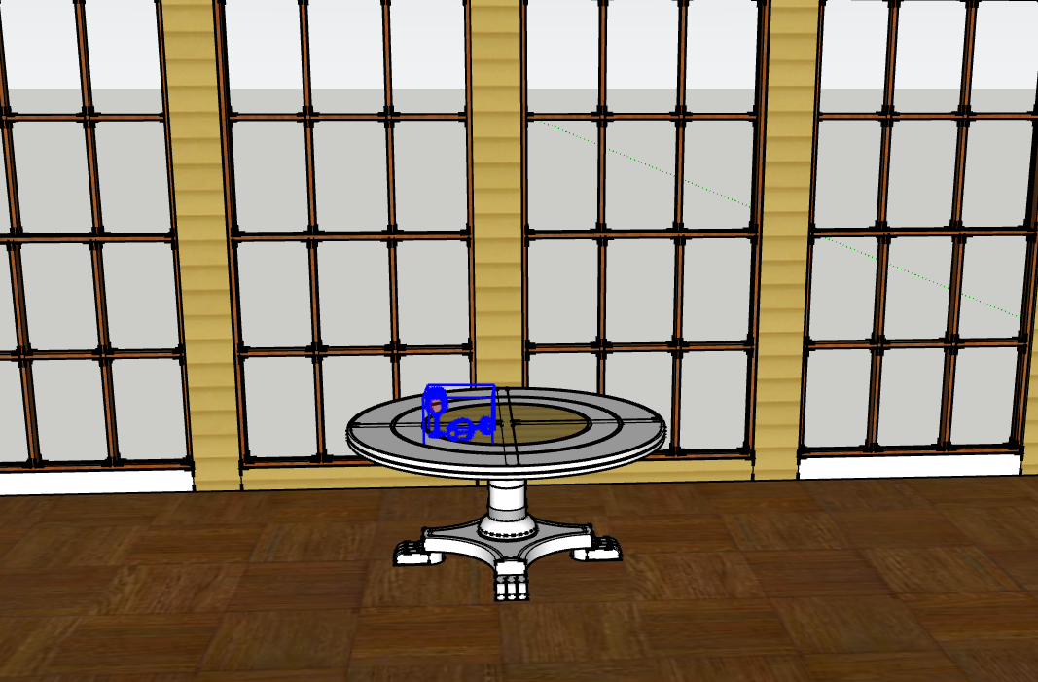
4) Scale & Floorplan Snapshot
Item | Dimension
Table Diameter | 900 mm
Table Height | 450 mm
Base Diameter | 400 mm
Room Area (concept) | 4m x 5m
Clearance Around | 600 mm minimum

5) 3D SketchUp Model – Features
- Materials Applied:
  - Chrome metal base
  - Smoked tempered glass top
  - Neon LED rim
- Backdrop Room:
  - Minimalist retro living space
  - Sunken seating + curved wall panels
  - Starburst light fixture for theme consistency

6) AutoCAD 2D Drawing Requirements
Sheet | Content
Sheet 1 | Overview with dimensions
Sheet 2 | Front, Top, Right Elevations
Sheet 3 | Detail of glass fixing joint
Sheet 4 | Base assembly + LED housing detail
- Includes:
  - Connection screws
  - Glass support brackets
  - Power port for LED
  - Material labels + fabrication notes

Side:
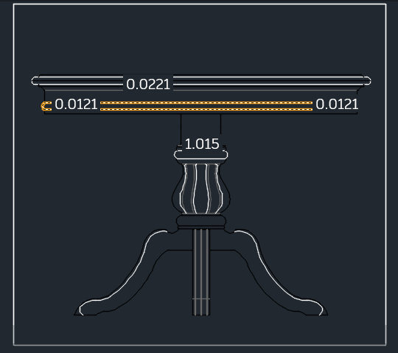

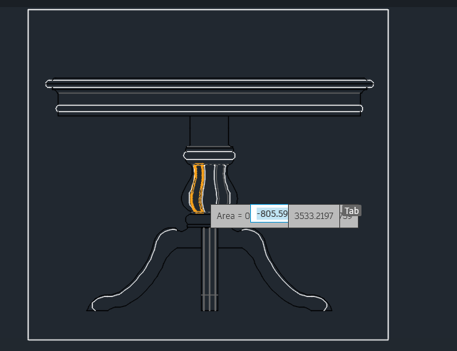
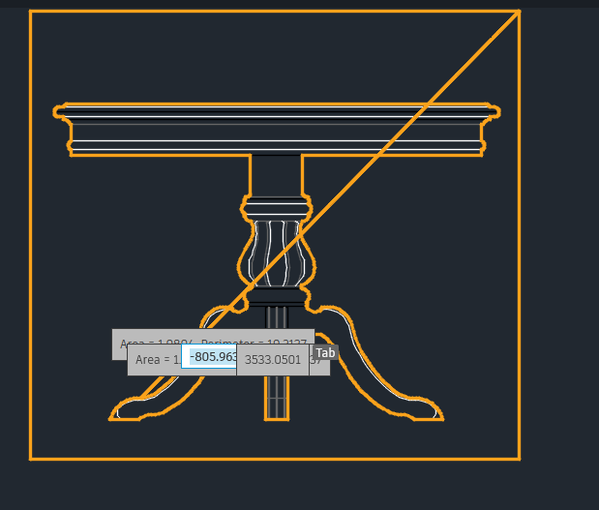

Top:
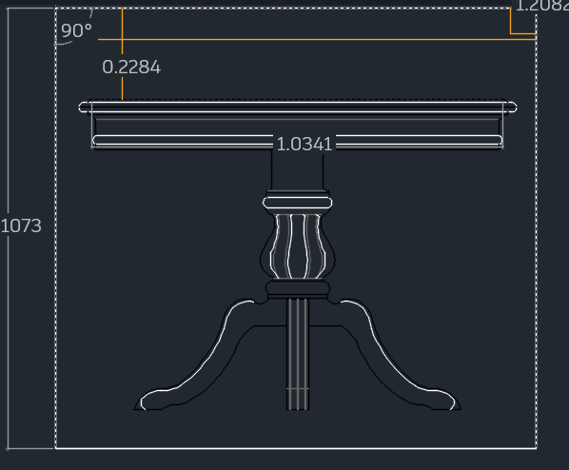

Side
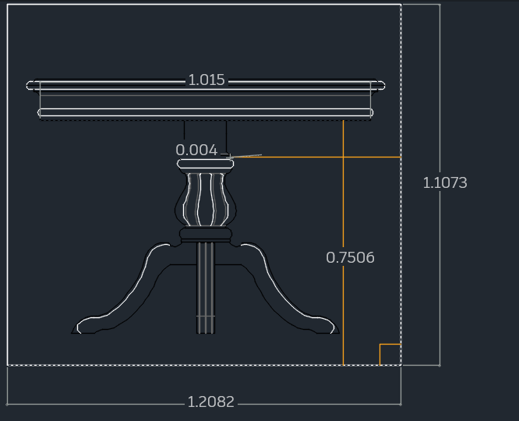
7) Concept Presentation Board (24" x 36")
Sections Included:
- Project Title & Title Block
- Design Concept Sketches
- Retro Futurism Reference Images
- Final 3D Render Views (4 angles + close-up)
- 2D Plans & Elevations with Dimensions
- Materials & Finishes Key
- Design Brief Summary

8) Design Brief (Short)
- The Orbitron Table 2095 celebrates retro futurism by combining classic space-age curves with modern minimal transparency.
- The floating glass surface mirrors the visual language of orbital structures, while the chrome base reflects 1950s optimism for the future.
- Integrated lighting reinforces the illusion of weightlessness and technological advancement.

9) Technical Specifications
Component | Material | Finish
Glass Top | Tempered Glass | Smoked, 12mm
Base | Stainless Steel | Mirror Chrome
LED Ring | Silicone strip | Neon Orange
Fixings | Steel Brackets | Matte Silver

References
Kirkpatrick, J. M., & Assadipour, H. (2021). AutoCAD for Interior design and space planning. Pearson.
Nyemba, W. R. (2022). Computer aided design: Engineering design and modeling using AutoCAD. CRC Press.
Tickoo, S. (2023). AutoCAD Plant 3D 2024 for Designers. Cadcim Technologies.

